
THE 5th INTERNATIONAL CONFERENCE ON YAK

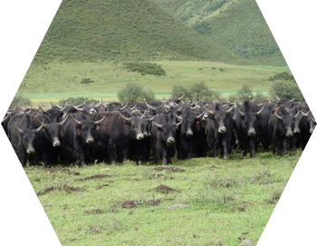

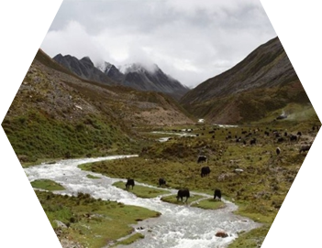
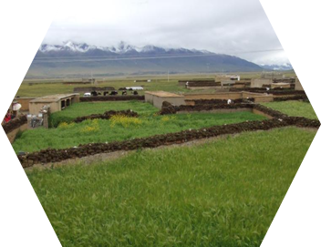

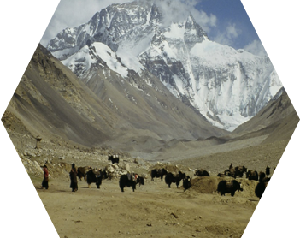

27-30 August, 2014, Lanzhou, China
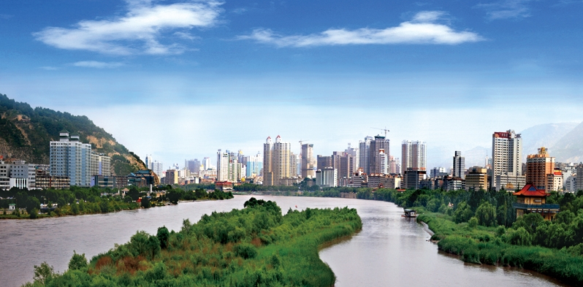

ORGANIZATION
Lanzhou Institute of Husbandry and Pharmaceutical Sciences CAAS
CO- ORGANIZATION
Yak and Camel Foundation of Germany
International Center for Integrated Mountain Development (ICIMOD)
ORGANIZATION COMMITTEE
Honorary Chairperson:
Prof. Dr. Heiner Niemann (Head of Institute, Head of Department Biotechnology, Institute of Farm Animal Genetics, Germany)
Prof. Dr. Ning Li (Academician, China Agricultural University)
Prof. Dr. Zhibiao Nan (Academician, Lanzhou University)
Prof. Zhiqiang Yang (Director of Lanzhou Institute of Husbandry and Pharmaceutical Sciences CAAS)
Chairperson:
Prof. Dr. Ping Yan (Deputy Director of Lanzhou Institute of Husbandry and Pharmaceutical Sciences CAAS)
General Secretary:
Dr. Xuezhi Wang (Director of Science & Technology Management Department, Lanzhou Institute of Husbandry and Pharmaceutical Sciences CAAS)
Chunnian Liang (Associate Research Fellow, Lanzhou Institute of Husbandry and Pharmaceutical Sciences CAAS)
SCIENTIFIC COMMITTEE:
Honorary Director
Prof. Dr. Horst Geilhausen (President of the Yak and Camel Foundation, Germany)
Director
Prof. Dr. Ning Wu（ICIMOD）

Members
Prof. Dr. Prof. Dr. JianPing Wu (China)
Prof. Dr. FuJiang Hou (China)
Prof. Dr. RuiJun Long (China)
Prof. Dr. JianLin Han (China)
Prof. Dr. ShuJie Liu (China)
Prof. Dr. JinCheng Zhong (China)
Prof. Dr. QiuMei Ji (China)
Prof. Dr. Xiaolin Luo (China)
Prof. Dr. Chunnian Liang (China)
Assistant Secretary:
Dr. Xuezhi Ding, Dr. Pengjia Bao, Dr. Min Chu, Dr. Hongbo Wang, Dr. Jie Pei
Topics:
Sustainable Development of Yak Husbandry
Climate Change and Environment
Genetics Resources and Breeding
Grazing Systems
Nutrition and Feeds
Reproduction and Physiology
Diseases and Health Service
MANUSCRIPT SUBMISSION
Manuscripts must be submitted by one of the authors of the manuscript, and should not be submitted by anyone on their behalf. The principal/corresponding author will be required to submit a cover Letter along with the manuscript, on behalf of all the co-authors (if any). The author(s) will confirm that the manuscript (or any part of it) has not been published previously or is not under consideration for publication elsewhere. Furthermore, any illustration, structure or table that has been published elsewhere must be reported, and copyright permission for reproduction must be obtained.
The manuscript should be written in English in a clear, direct and active style. All pages must be numbered sequentially, facilitating in the reviewing and editing of the manuscript. The deadline for submission abstract is May 31, 2014.
For further convenience, please following the standard "Format for Paper Preparation" provided by the organizer. Extended abstracts must be submitted as attached files by email to the organization committee at
yakconference@163.com； mykyc204@126.com
PROGRAM
Date | Morning |  | Afternoon
27Aug | Registration
28Aug | Opening Ceremony | Plenary  Session | Concurrent  Scientific  Sessions
29Aug | Plenary  Session | Concurrent  Scientific  Sessions | Concurrent  Scientific  Sessions
30Aug | Field Trip-Qinghai Datong Yak Farm

REGESTRATION INFORMATION
Registration fee
Category | Before 1 April 2014 | From 1 April 2014
Participant | USD 300 (RMB1800) | USD 350 (RMB 2100)
student | USD 200 (RMB 1200) | USD 250 (RMB 1500)
Accompanying person | USD 150 (RMB 900) | USD150 (RMB 900)
1 USD=6.2 Yuan RMB
Accommodation
The registration fee is not including the accommodation; however, we provide the price of the hotel near the conference hall.
*The price of accommodation is as follows:
Price of Longneng Hotel
1) Hotel: Standard Room (2 persons) about RMB 440/day
2) Hotel: Single Room (1 persons) about RMB 440/day
3) Hotel: Business Suite (1 persons) about RMB 780/day
Price of Crowne Plaza Hotel
1) Hotel: Standard Room (2 persons) about RMB1280/day
2) Hotel: Single Room (1 persons) about RMB 1380/day
3) Hotel: Business Suite (1 persons) about RMB 1980/day
Address of Long Neng Hotel: No. 70 North Binhe East Road, Chengguan District, Lanzhou City
Address of Crowne Plaza Hotel: No. 1 North Binhe East Road, Chengguan District, Lanzhou City
FIELD TRIP Time: 07:00 -18:00, Aug 30, 2014 (Qinghai Datong Yak Farm)
Da-tong Yak Breeding Farm, Qinghai Province
Da-tong Yak Breeding Farm is about 320 km from Lanzhou city. The average altitude is about 3500m. The area is a typical pastoral zone in the alpine region of the Qinghai-Tibet Plateau. Highland animals can be found in this area, such as yak and Tibetan sheep. The inspection will focus on the alpine rangeland management and yaks grazing system.
‘The new Datong yak breed & comprehensive breeding technique’, which had been developed by the scientists of the Lanzhou Institute of Husbandry and Pharmaceutical Sciences of Chinese Academy of Agricultural Sciences on the Datong Yak Breeding Farm of Qinghai Province in the past 25 years, the process fully integrated the socioeconomics and natural environmental factors on the Qinghai-Tibetan Plateau. The Datong Yak is the only improved yak population developed deliberately by crossing wild yak bulls with domestic yak females with the intention of creating a new breed of yak. The new breed of yak with 1/2 gene in wild yak was bred, which was a beef yak. The Datong yak looks not dissimilar to the wild yak with its greyish-white mouth, nose, sockets and grey back line. The males are horned and females are either horned or hornless. The body conformation seems to be of a meat type with good body weight, straight back, a wide chest, and long, strong legs. The body color is typically black, though there may also be a few brown hairs. This breed has a rapid growth and development rate. Body weights of individuals in the born-6 months are respectively 15-27% higher than those of the born-18 months. It has relatively strong adversity resistance and adaptability. The overwintering death rate of this yak is 4% lower than the other yaks. The reproduction rate is relative high. The age at first delivery has been reduced from the original 4.5 years to 3.5 years. The multipara yak bears 2 fetuses in 3 years. The calving rate is 75%. This breed has strong adversity resistance and adaptability. This is reflected by the significantly reduced overwintering death rate, strong foraging ability, and a wide foraging range.
The world's first yak breed - Datong yak and related breeding & cultivation systems, which filled the blank in the history of the world's domesticated animal breeding, and first established the technique with the wild progenitor species like their wild relatives to cultivate new breeds, which providing a successful example for livestock breeding. The research finding was achieved based on China's special genetic resources with original technology, which has independent intellectual property right.
Because of the stable genetic characters of the Datong yak, which is, improved beef performance, resistance to adverse environments and adaptation to the high, cold or even extremely hibernal rangelands, the new breed is warmly welcomed by other yak production areas and plays a very important part in genetic improvement and rejuvenation of the domestic yak in those areas. At present, demand for breeding animals of the Datong yak is high, 25000 head of breeding bulls, 300000 frozen semen were widely application and coverage 75% the yak raising areas, which plays an important role in promoting the development of society, economy on the alpine region of minority groups .
Polled Domestic Yaks Breeding. To better exploit the advantages of hybridization，we are engaged in breeding Polled yaks in the coming years. Polled livestock are preferred by many farmers for a variety of reasons, the foremost being that horns can pose a physical danger to humans, other livestock and equipment. Horns may also interfere with equipment used with livestock (such as a cattle crush), or they may become damaged during handling. At present, we had cultivated 4 groups of hornless yaks with a number of 1200, the relative comprehensive studies such as quality and resistance properties are undergoing.
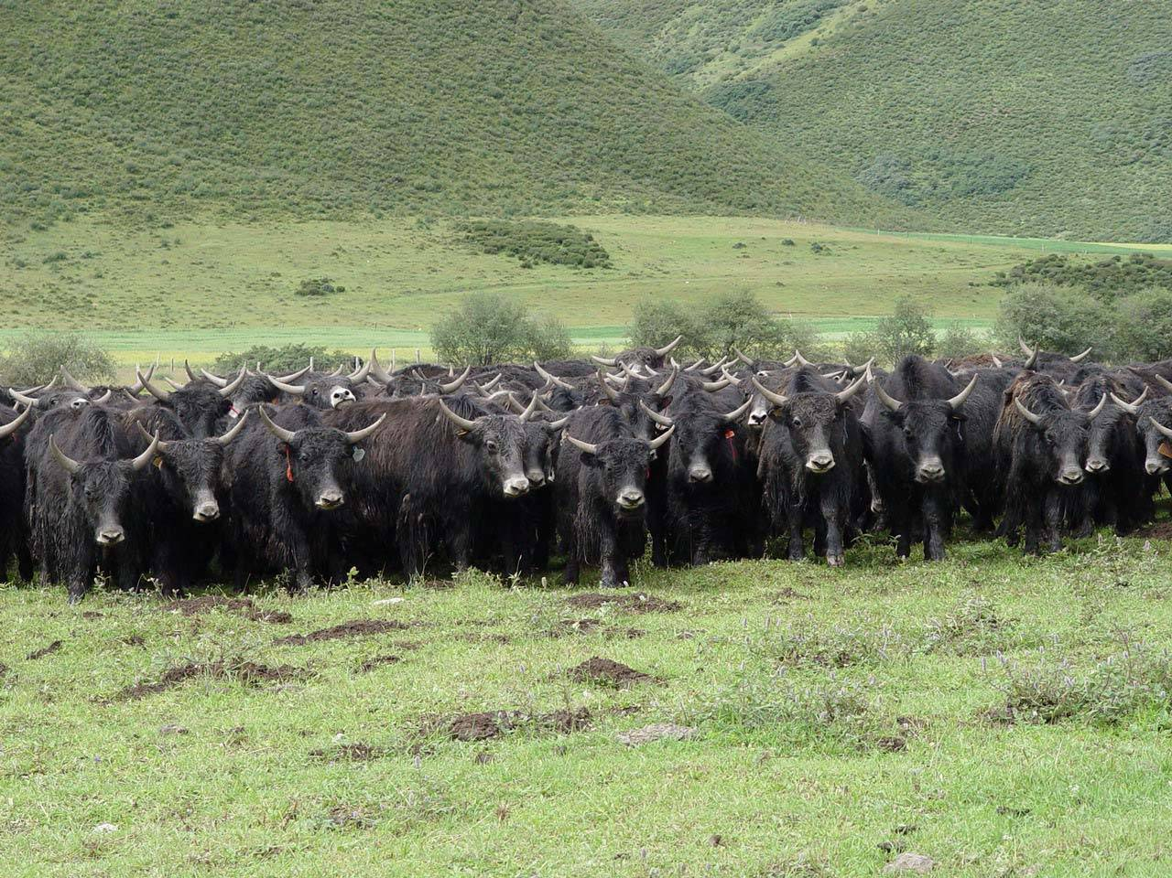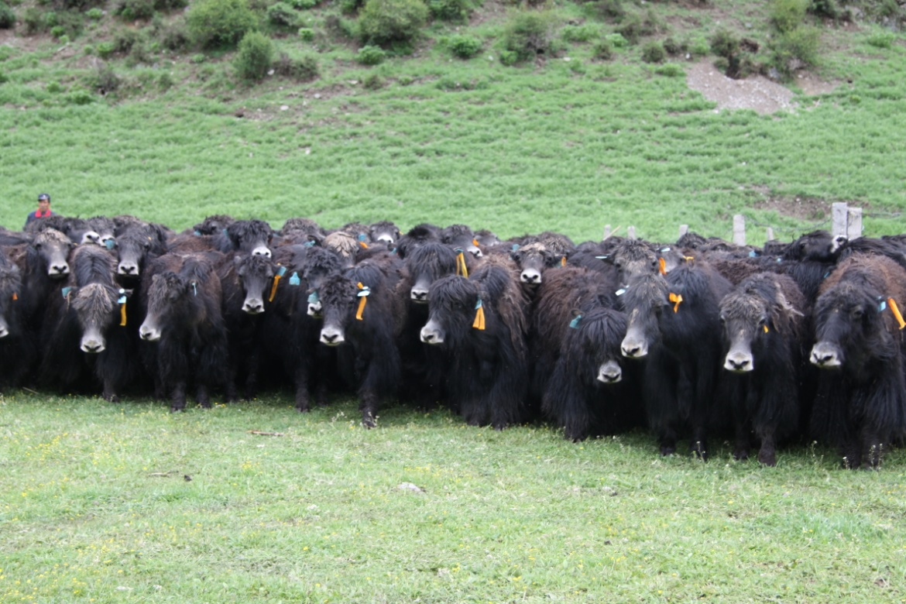
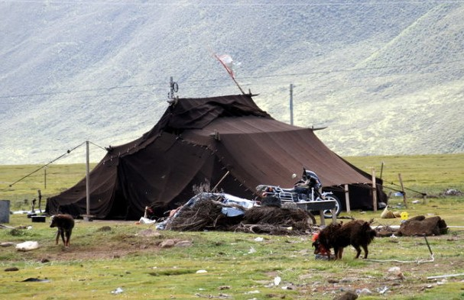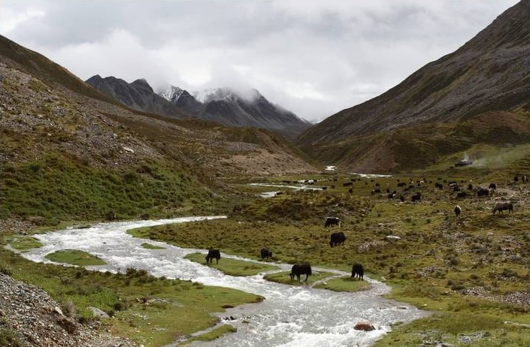

GENERAL INFORMATION
Conference venue (to be confirmed)
Lanzhou Institute of Husbandry and Pharmaceutical Sciences
The Lanzhou Institute of Husbandry and Pharmaceutical Sciences (LIHPS) is dedicated to addressing major scientific issues related to livestock production. Specifically, LIHPS is focused on four research areas: animal husbandry, veterinary medicine, traditional Chinese veterinary medicine (TCVM), and prataculture. Many of the institute’s studies are dedicated to developing sustainable breeding techniques for Tibetan sheep and yak, and immunological approaches to enhance the fertility of ewes using a steroid antigen. Moreover, researchers at LIHPS are developing chemical and biological medicines along with TCVM compounds for veterinary use, as well as safety evaluations for these medicines. The institute also investigates metabolic and poisoning diseases, dairy cow diseases, and ways to enhance veterinary surgery with acupuncture anesthesia. In addition, LIHPS focuses on improving and constructing grasslands and cultivating new pasture varieties.
LIHPS has built 15 scientific research facilities that provide invaluable support to scientific researchers, including the Quality Supervision, Inspection, and Testing Center of MOA for Animal Fiber, Fur, Leather, and Products (Lanzhou); the Scientific Observation and Experiment Field Station of MOA for Ecological Systems in Loess Plateau Areas (Lanzhou); the Key Lab of MOA for Veterinary Pharmaceutical Development; the Research Center of CAAS for Risk Assessment on Quality and Safety of Animal Products (Lanzhou); and the Key Laboratory of Gansu Province for Yak Breeding.
Since its establishment, LIHPS has undertaken 940 scientific research projects and won 201 awards, including 12 national awards and 114 provincial awards. The institute has also been awarded 37 patents, 56 new certificates of veterinary medicine, and three new national certificates of veterinary medicine. A new yak breed named “Datong yak,” for which the LIHPS received the independent intellectual property rights, is a momentous advance for yak breeding throughout the world.
LIHPS is also the host institute for the Veterinary Toxicology Special Committee of the Chinese Society of Toxicology, the Northwest Pathology Branch and the Northwest Chinese Veterinary Medicine Branch of Chinese Association of Animal Science and Veterinary Medicine, and the National Yak Breeding Cooperative Group.

Location of Lanzhou city
Lanzhou is the capital city of Gansu Province in northwest China. The Yellow River (called the Mother River of China) runs through Lanzhou City from the west to the east, with mountains in the south and north of the city. As Lanzhou is the only provincial city through which the Mother River runs. Whether you choose to roam along the River, to cross the First Bridge over the Yellow River, or to have a cup of eight auspicious teas at the Waterwheel Park, you will be impressed by Lanzhou with its harmonious combination of the modern and the old.

Climate
Lanzhou is situated in the temperate zone and enjoys a semi-arid climate (Köppen BSk) with hot summers and cold and very dry winters. The monthly 24-hour average temperature ranges from −5.3 °C (22.5 °F) in January to 22.4 °C (72.3 °F) in July. The mean annual temperature is 9.75 °C (49.5 °F), while annual rainfall is 315 millimetres (12.4 in), almost all of which falls from May to October. The winters are so dry that snow is extremely rare. Sunshine is generous, with no month having less than 50% of the potential, but not particularly abundant, averaging 2,424 hours annually.
Transportation
By Air
Lanzhou Zhongchuan Airport (ZGC) is located about 70 kilometers from the downtown area. More than 30 airlines connect Lanzhou to the outside world, with daily flights to and from Beijing, Shanghai, Guangzhou, Shenzhen and Xi'an. The direct daily flights to and from Lhasa now is available and the whole flight lasts only 2.5 hours. Flights to major cities like Tianjin, Chengdu, Chongqing, Nanjing, Kunming, Hangzhou, Taiyuan, Jinan, Changsha, Haikou, Wuhan, Wenzhou, Xiamen, Zhuhai and Shenyang are also available from Lanzhou Zhongchuan Airport.
You can take the airport shuttle bus to arrive Lanzhou city. It takes roughly an hour for the airport shuttle bus (at about 30 RMB per person) to arrive at Lanzhou Eastern Hotel (No. 555, Tianshui Road) at downtown just the opposite of the Main Gate of Lanzhou University, and then take a taxi to the Long Neng Hotel (the registration hotel).
Your Paper's Title Starts Here: Please Center
use Helvetica (Arial) 14
First Author^{1, a}, Second Author^{2,b} and Others^{3,c}
¹Full address of first author, including country
²Full address of second author, including country
³List all distinct addresses in the same way
ªemail, ^{b}email, ^{c}email
Keywords: List the keywords covered in your paper. These keywords will also be used by the publisher to produce a keyword index.
For the rest of the paper, please use Times Roman (Times New Roman) 12
Abstract. This document explains and demonstrates how to prepare your camera-ready manuscript for Trans Tech Publications. The best is to read these instructions and follow the outline of this text. The text area for your manuscript must be 17 cm wide and 25 cm high (6.7 and 9.8 inches, resp.). Do not place any text outside this area. Use good quality, white paper of approximately 21 x 29 cm or 8 x 11 inches (please do not change the document setting from A4 to letter). Your manuscript will be reduced by approximately 20% by the publisher. Please keep this in mind when designing your figures and tables etc.
Introduction
All manuscripts must be in English. Please keep a second copy of your manuscript in your office (just in case anything gets lost in the mail). When receiving the manuscript, we assume that the corresponding authors grant us the copyright to use the manuscript for the book or journal in question. Should authors use tables or figures from other Publications, they must ask the corresponding publishers to grant them the right to publish this material in their paper.
Use italic for emphasizing a word or phrase. Do not use boldface typing or capital letters except for section headings (cf. remarks on section headings, below). Use a laser printer, not a matrix dot printer.
Organization of the Text
Section Headings. The section headings are in boldface capital and lowercase letters. Second level headings are typed as part of the succeeding paragraph (like the subsection heading of this paragraph).
Page Numbers. Do not print page numbers: Please number each sheet toward the middle near the bottom (outside the typing area) with a soft pencil.
Tables. Tables (refer with: Table 1, Table 2, ...) should be presented as part of the text, but in such a way as to avoid confusion with the text. A descriptive title should be placed above each table. The caption should be self-contained and placed below or beside the table. Units in tables should be given in square brackets [meV]. If square brackets are not available, use curly {meV} or standard brackets (meV).
Figures. Figures (refer with: Fig. 1, Fig. 2 ...) also should be presented as part of the text, leaving enough space so that the caption will not be confused with the text. The caption should be self-contained and placed below or beside the figure. Generally, only original drawings or photographic reproductions are acceptable. Only very good photocopies are acceptable. Utmost care must be taken to insert the figures in correct alignment with the text. Half-tone pictures should be in the form of glossy prints. If possible, please include your figures as graphic images in the electronic version. For best quality the pictures should have a resolution of 300 dpi (dots per inch

Equations. Equations (refer with: Eq. 1, Eq. 2, ...) should be indented 5 mm (0.2"). There should be one line of space above the equation and one line of space below it before the text continues. The equations have to be numbered sequentially, and the number put in parentheses at the right-hand edge of the text. Equations should be punctuated as if they were an ordinary part of the text. Punctuation appears after the equation but before the equation number, e.g.
c² = a² + b². (1)
Literature References
References are cited in the text just by square brackets [1]. (If square brackets are not available, slashes may be used instead, e.g. /2/.) Two or more references at a time may be put in one set of brackets [3,4]. The references are to be numbered in the order in which they are cited in the text and are to be listed at the end of the contribution under a heading References, see our example below.
Summary
On your CD, please indicate the format and word processor used. Please also provide your phone number, fax number and e-mail address for rapid communication with the publisher. Please always send your CD along with a hard copy that must match the CD’s content exactly. If you follow the foregoing, your paper will conform to the requirements of the publisher and facilitate a problem-free publication process.
References
[1] Dj.M. Maric, P.F. Meier and S.K. Estreicher: Mater. Sci. Forum Vol. 83-87 (1992), pp. 119-125
[2] M.A. Green: High Efficiency Silicon Solar Cells (Trans Tech Publications, Switzerland 1987).
[3] Y. Mishing, in: Diffusion Processes in Advanced Technological Materials, edtied by D. Gupta Noyes Publications/William Andrew Publising, Norwich, NY (2004), in press.
[4] G. Henkelman, G.Johannesson and H. Jónsson, in: Theoretical Methods in Condencsed Phase Chemistry, edited by S.D. Schwartz, volume 5 of Progress in Theoretical Chemistry and Physics, chapter, 10, Kluwer Academic Publishers (2000).
[5] R.J. Ong, J.T. Dawley and P.G. Clem: submitted to Journal of Materials Research (2003)
[6] P.G. Clem, M. Rodriguez, J.A. Voigt and C.S. Ashley, U.S. Patent 6,231,666. (2001)
[7] Information on http://www.weld.labs.gov.cn

Appendix：
ICY 2014
Registration Form
Title (Prof, Dr, Mr, Mrs)
First (given) name
Last (Family) name
Organization
Postal Address
City & State
Postcode
Country
Telephone
Fax
Email
Paper presentation | Yes No
Title of paper
Mode of presentation | Oral Poster
Amount being paid | USD RMB Amount:
Room booking (type and quantity)

